Exercise for chapter 10
- When we test H₀: μ₁ ≤ μ₂, H_{A}: μ₁ > μ₂ at α = .10, where 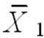 = 77.4, 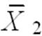 = 72.2, s₁ = 3.3, s₂ = 2.1, n₁ = 6, n₂ = 6, what is the conclusion?
Solution: H₀: μ₁ ≤ μ₂, H_{A}: μ₁ > μ₂
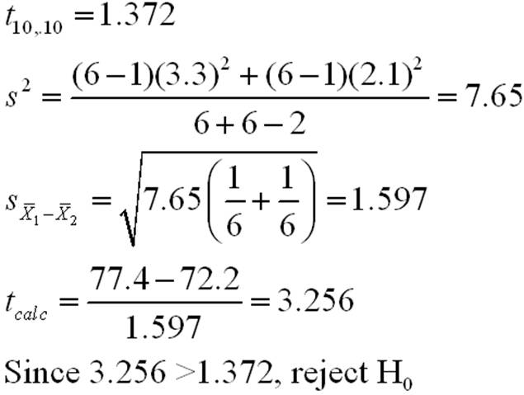

- A test of driving ability is given to a random sample of 10 student drivers before and after they complete a formal driver education course. Results follow.
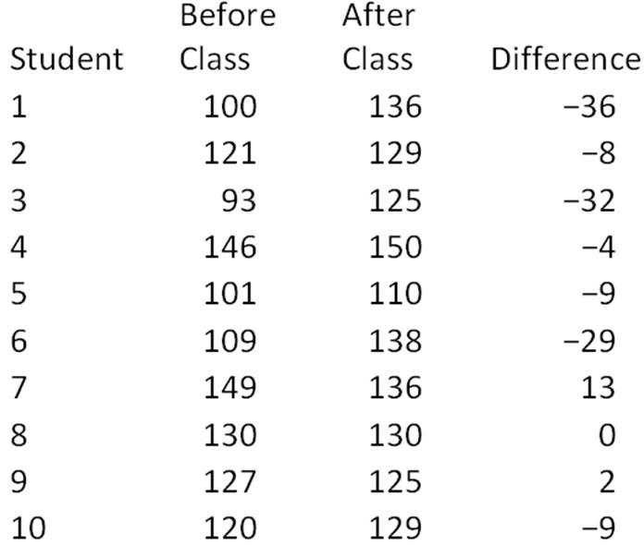
Test the hypothesis that there is no difference between the before class scores and the after-class scores at α = .05.

Solution: 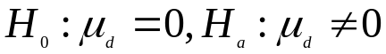

Mean = -11.2
std dev/√n = 5.078933
t = -11.2/5.08 = -2.21
Critical value 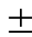t_{.025} = 2.26 for df = 9
Since 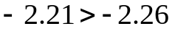
Cannot reject the null hypothesis that there is no difference between the before-class scores and the after-class scores.

3. A marketing research company surveyed grocery shoppers on the East Coast and West Coast to see the percentage of the customers who prefer chicken to other meat. The data are given below.

Is the proportion of customers who prefer chicken higher at the West Coast? Test at α = .05.
Solution: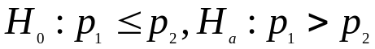
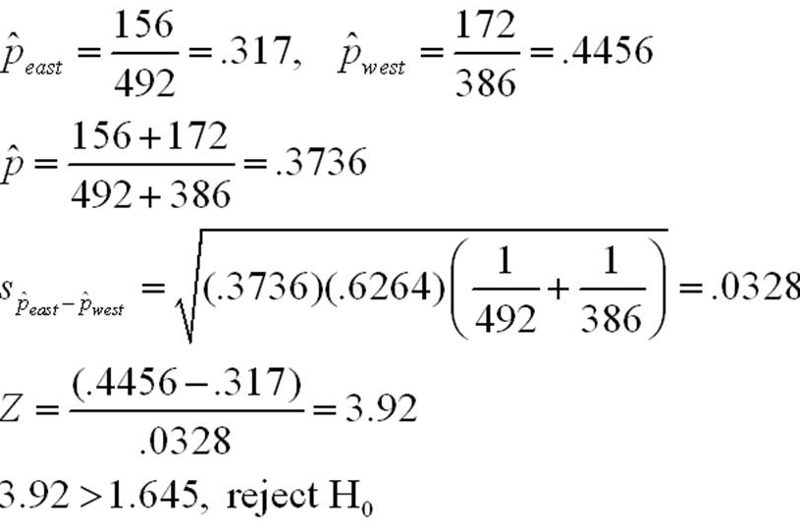
The proportion is higher on the West Coast. Reject the null hypothesis.
4. The mid-distance running coach, Zdravko Popovich, for the Olympic team of an eastern European country claims that his six-month training program significantly reduces the average time to complete a 1500-meter run. Five mid-distance runners were randomly selected before they were trained with coach Popovich's six-month training program, and their completion times (in minutes) of the 1500-meter run were recorded. After six months of training under coach Popovich, the same five runners' 1500-meter run times were recorded again. The results are given below.
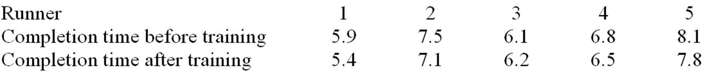
At an alpha level of .05, can we conclude that there has been a significant decrease in the mean time per mile?
Solution:
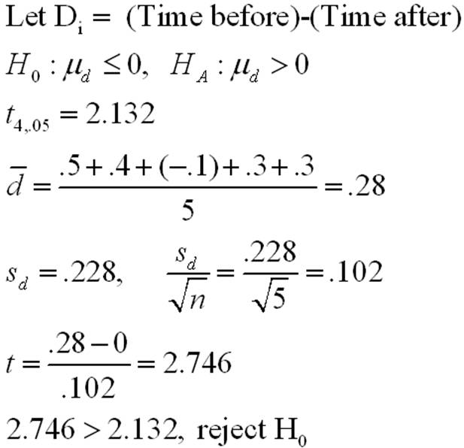
Yes, there is a significant decrease in the mean time per mile. That is, reject the null hypothesis.
5. When we test H₀: μ₁ - μ₂ ≤ 0, H_{A}: μ₁ - μ₂ > 0, 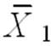 = 15.4, 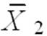 = 14.5, σ₁ = 2, σ₂ = 2.28, n₁ = 35, and n₂ = 18 at α = .01, what is your conclusion?
Solution: Z= ((15.4 - 14.5) - 0)/√[(2²/35) + (2.28²/18)] = .9/.635 = 1.42
Critical value is 2.33, since 1.42<2.33
We can’t reject the null hypothesis.

6. | A marketing research company surveyed grocery shoppers on the East Coast and West Coast to see the percentage of the customers who prefer chicken to other meat. The data are given below.    Is the proportion of customers who prefer chicken different for the two regions? Test at α = .10.  Solution: 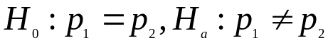  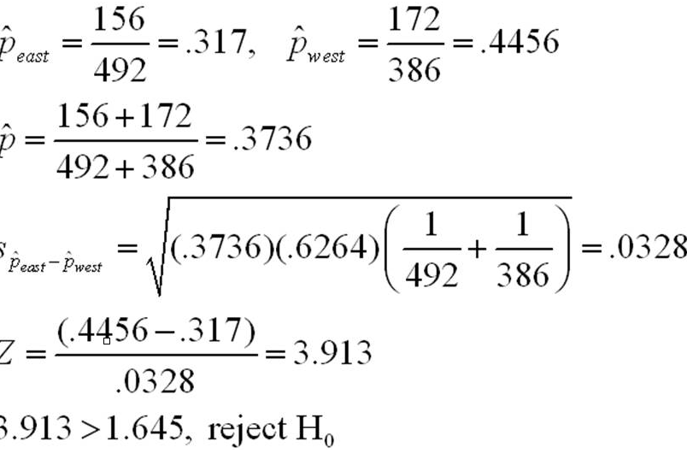  The proportion of customers is not the same for the two regions. Reject the null hypothesis.
7. A fast food company uses two management-training methods. Method 1 is a traditional method of training and Method 2 is a new and innovative method. The company has just hired 31 new management trainees. 15 of the trainees are randomly selected and assigned to the first method, and the remaining 16 trainees are assigned to the second training method. After three months of training, the management trainees took a standardized test. The test was designed to evaluate their performance and learning from training. The sample mean score and sample standard deviation of the two methods are given below. The management wants to determine if the company should implement the new training method. We assume the population variance are equal for the two populations.
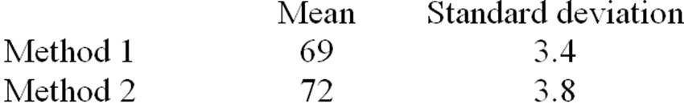
Is there evidence at α = .01 to conclude that the new training method is more effective than the traditional training method?
Solution: 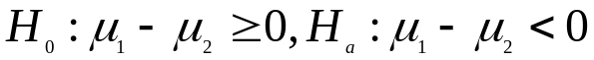
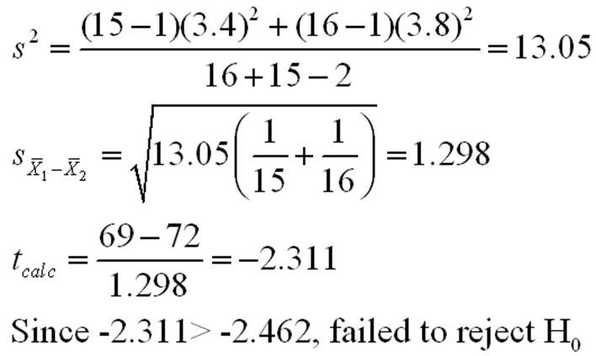
No, there is not sufficient evidence to reject the null hypothesis.
We can’t conclude the new training method is more effective than the traditional training method.

